Autonomous Driving: Driver Assistance/Training Module #1

*Sensor only*

Jingwen Mo

Supervised by Prof. Quoc-Viet Dang

July 5th, 2018

**Abstract**

This project works toward autonomous driving in a racing environment through a driver assistance/training module. For this prototype, an Arduino is paired with an ultrasonic sensor to detect distances from nearby objects at 3 different configurable ranges. The information is relayed back to the driver via LED lights for immediate feedback. Traditionally, this information is only available after a racing lap is completed through video, estimated manually, and is not as accurate as using automated sensors.

1. **Introduction**

Ultrasonic sensors, or sonar sensors, are a form of sensors that use echolocation to sense objects around it. It's the same principle as the echolocation that whales and bats use to find food or objects when they travel. By emitting a certain frequency and seeing how long it takes for it to come back, we can determine the location and even the speed of an object.

1. **Testing Environment**

I have set three positive test cases for driver assistance/training module:

1) Green Light: < 10cm away

2) Yellow Light: between 10cm to < 30cm away

3) Red Light: between 30cm to < 60 cm away

4) No lights: 60cm or greater away

* 1. Green Light

When the object is quite close to our vehicle(less than 10 cm), the ultrasonic sensor will sense the distance and turn the green light on because that is the distance we want as shown below.

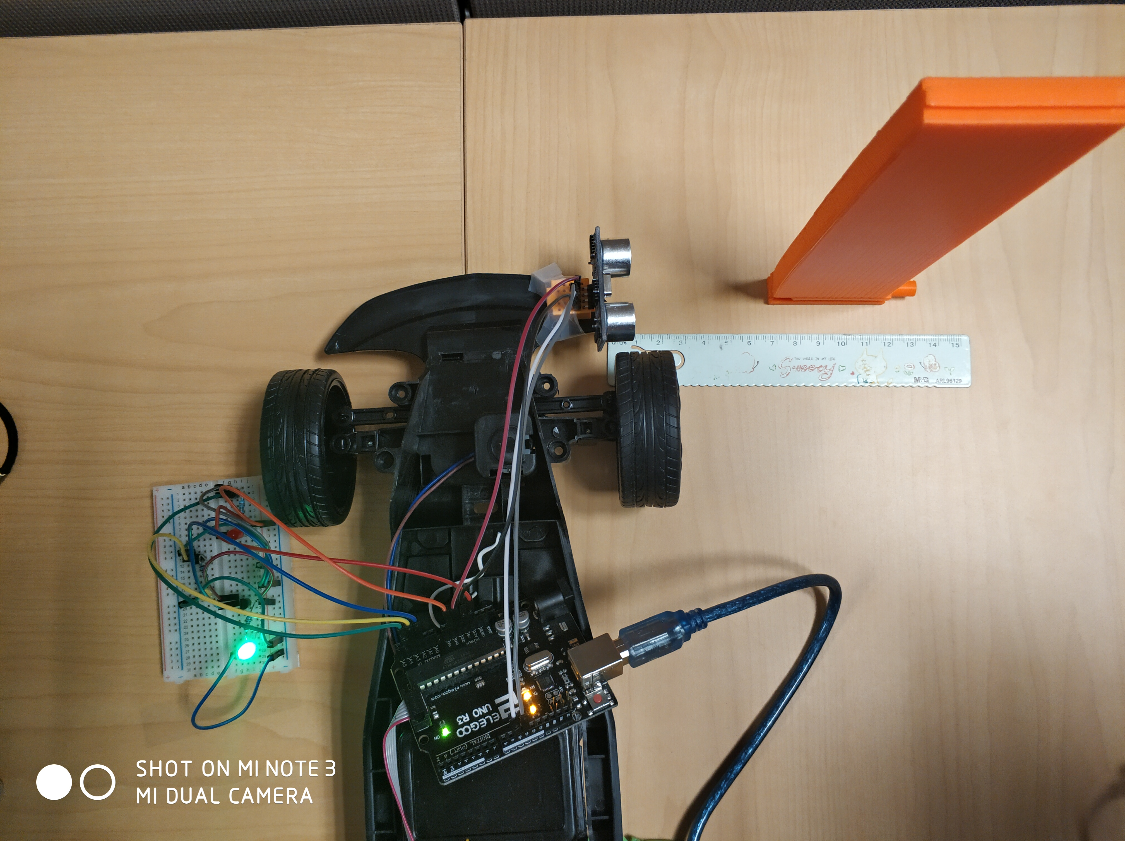

  This is the screenshot of the terminal showing the distance output in text.

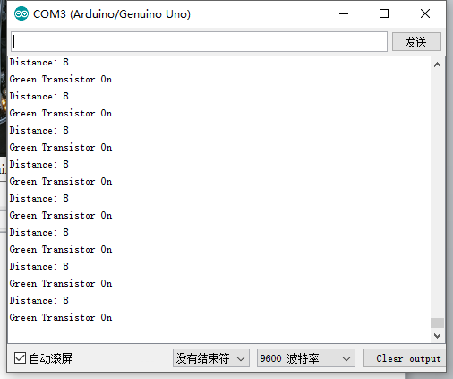

2.2 Yellow Light

When the object is close to our vehicle( less than 30 cm and more than 10 cm), the ultrasonic sensor will sense the distance and turn the yellow light on to send out an information that you are not close enough and you can get closer as shown below .

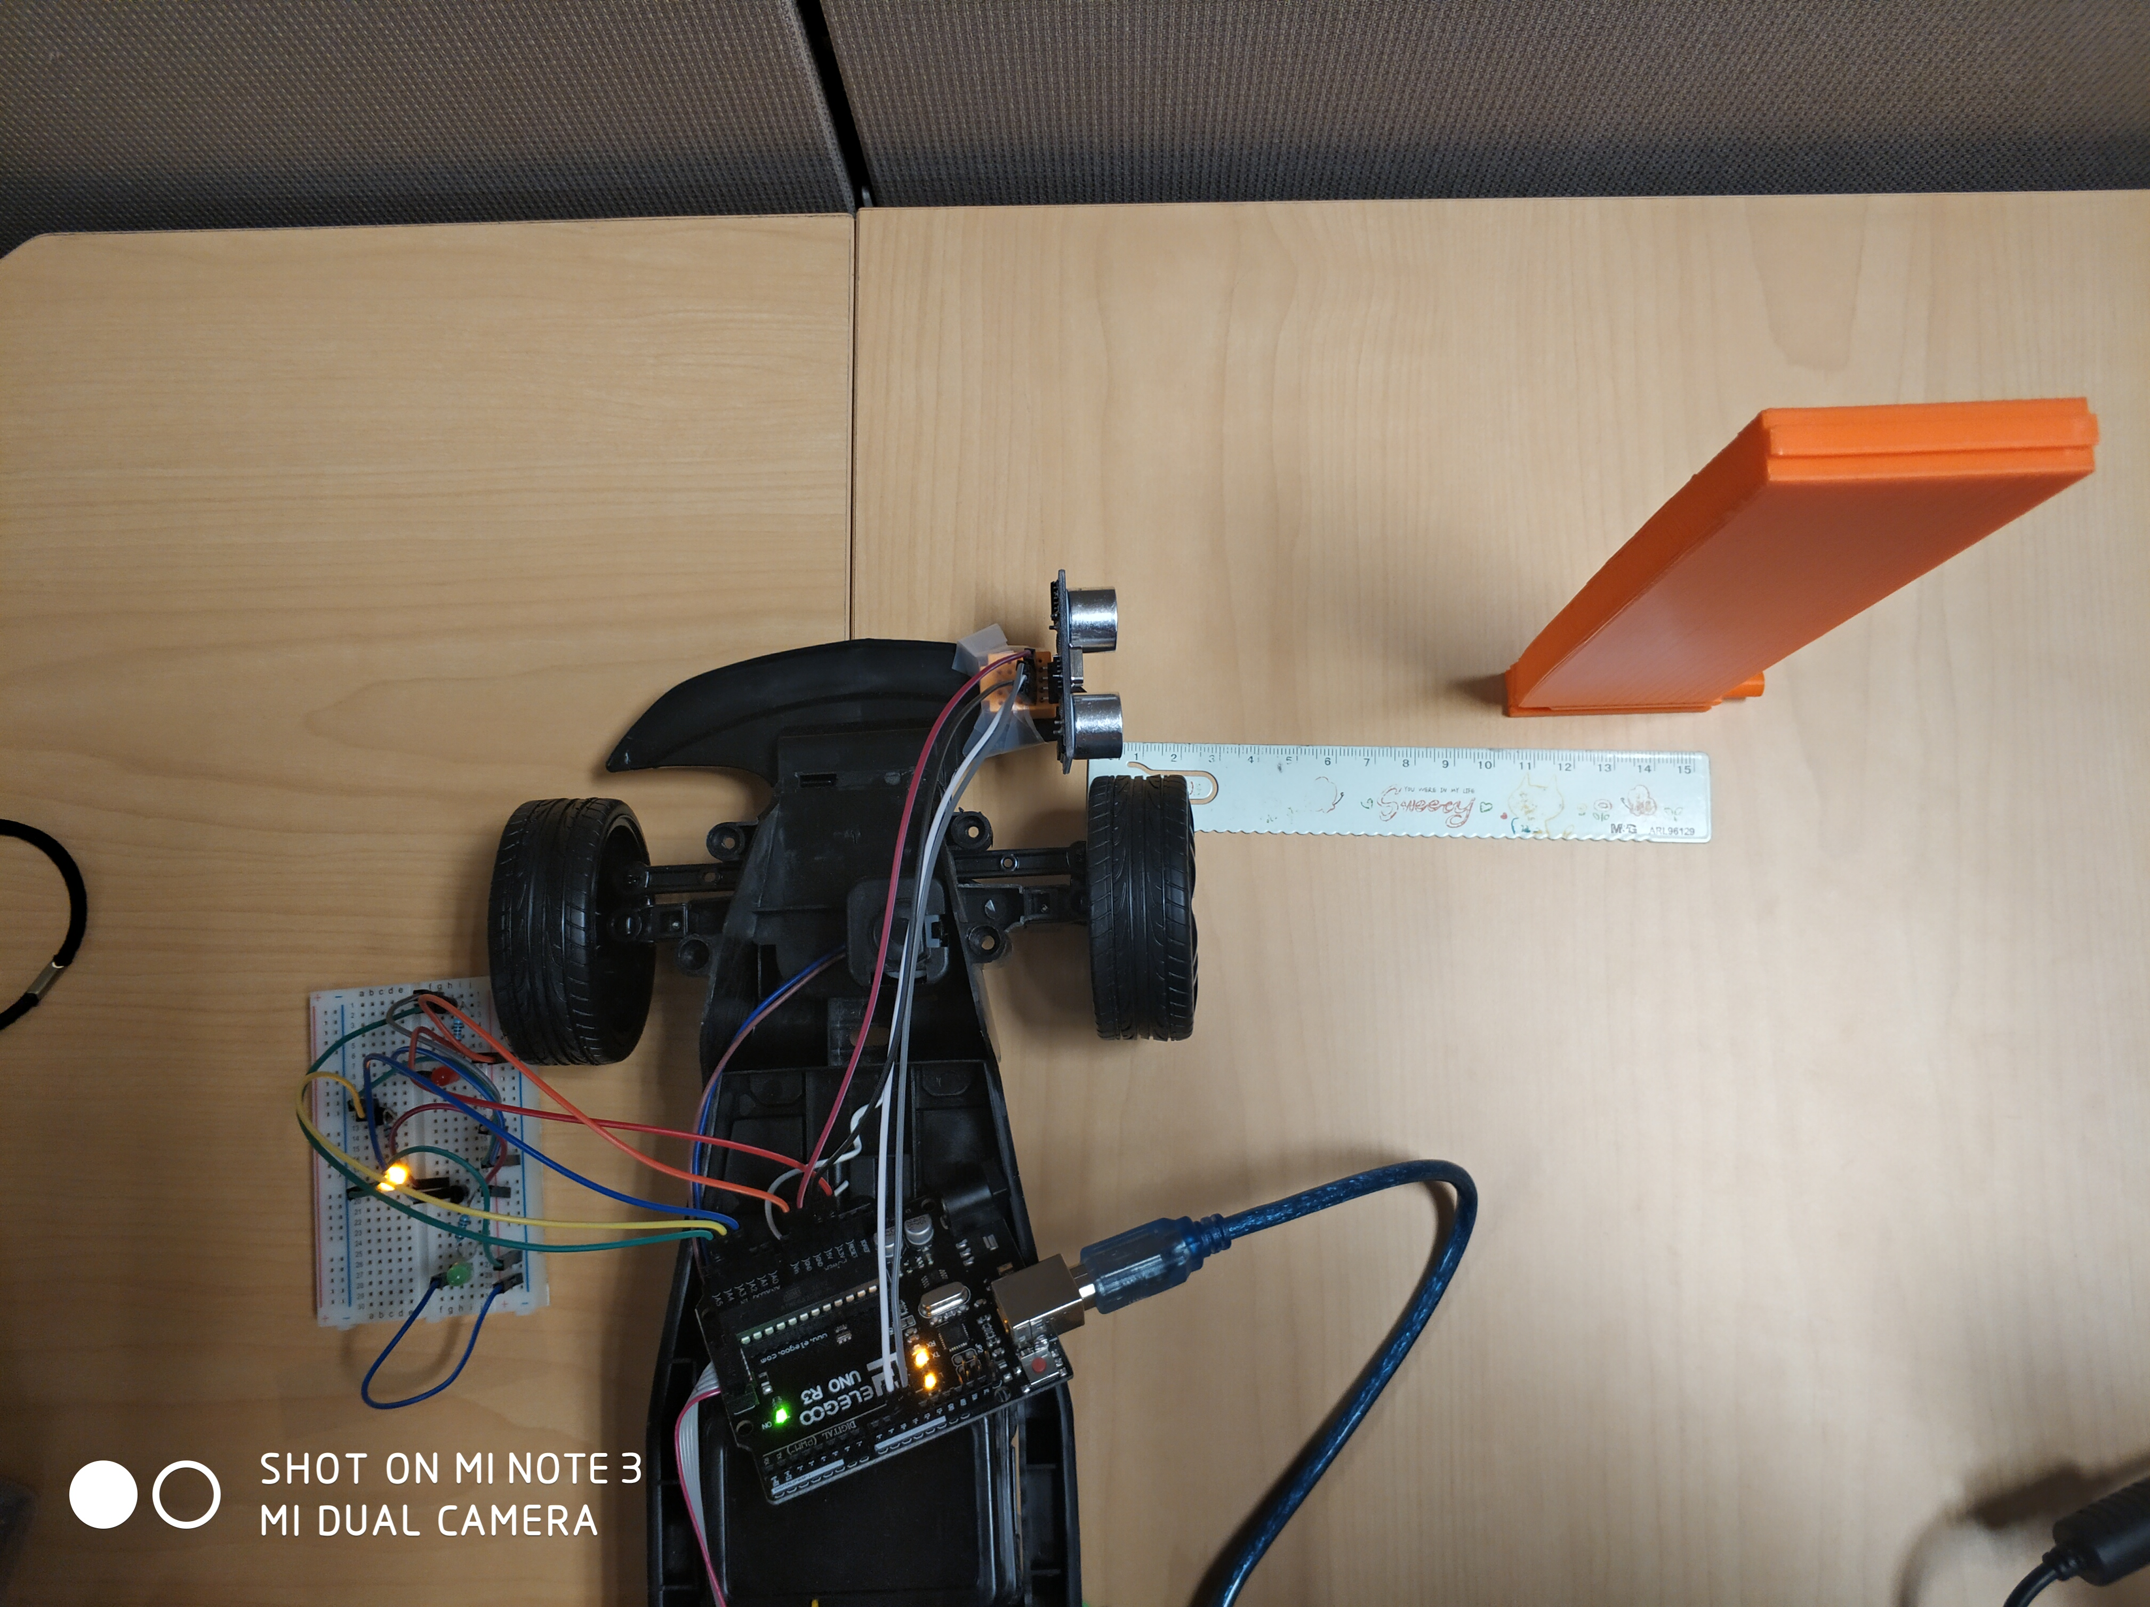

This is the screenshot of the terminal showing the distance output in text.

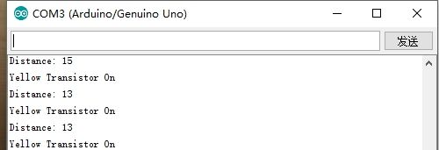

2.3 Red Light

When the object is a little far from our vehicle( more than 30 cm and less than 60 cm), the ultrasonic sensor will sense the distance and turn the red light on to send out an information that you are far away and you should get closer as shown below .

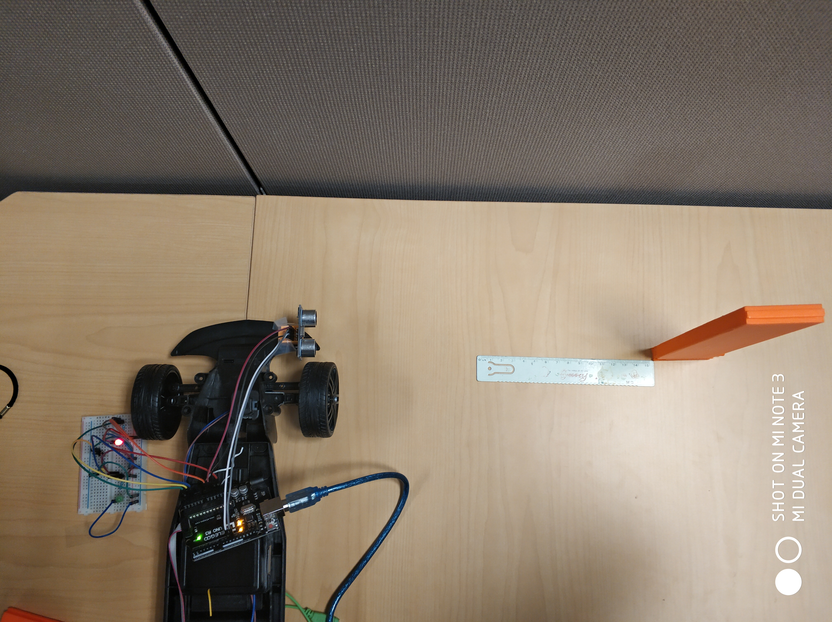

This is the screenshot of the terminal showing the distance output in text.

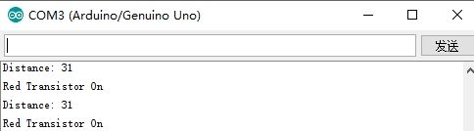

2.4 No lights

When the object is enough far from our vehicle( more than 60 cm), there will be no light turned on as shown below.

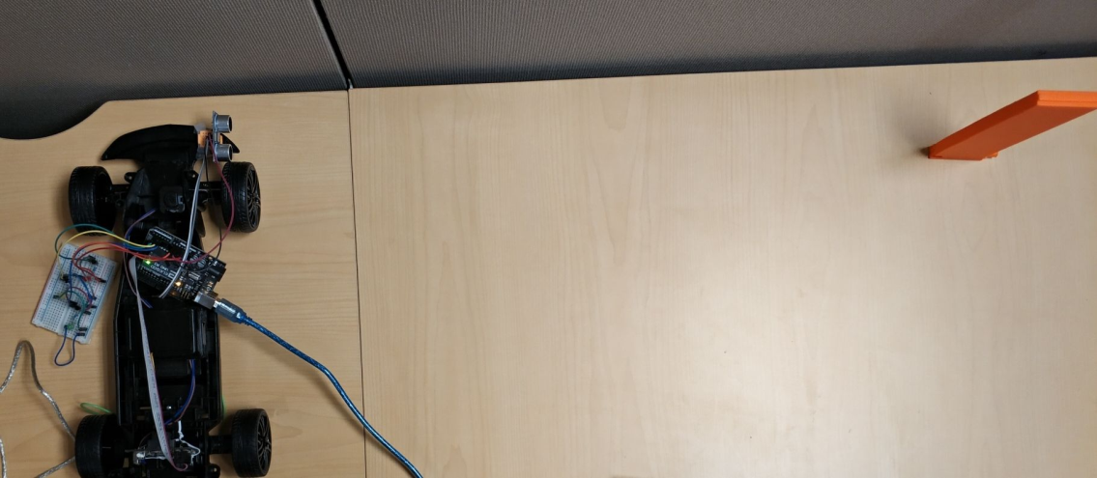

This is the screenshot of the terminal showing the distance output in text.

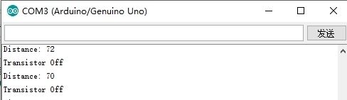

1. **References**

<https://www.arduino.cc/>

<http://forefront.io/a/beginners-guide-to-arduino/>

<https://howtomechatronics.com/tutorials/arduino/ultrasonic-sensor-hc-sr04/>

<https://www.allaboutcircuits.com/projects/turning-on-a-light-with-ultrasonic-motion-detection/>